1)

**AIM** : To create an Student Registration Form

**DESCRIPTION** :

* An HTML form is used to collect user input. The user input is most often sent to a server for processing.
* The HTML <form> element is used to create an HTML form for user input
* The <form> element is a container for different types of input elements, such as: text fields, checkboxes, radio buttons, submit buttons, etc.
* The HTML <input> element is the most used form element.
* An <input> element can be displayed in many ways, depending on the type attribute.
* The <input type="text"> defines a single-line input field for text input.
* The <label> element is useful for screen-reader users, because the screen-reader will read out loud the label when the user focus on the input element.
* The <input type="radio"> defines a radio button.
* Radio buttons let a user select ONE of a limited number of choices.
* The <input type="checkbox"> defines a checkbox.
* Checkboxes let a user select ZERO or MORE options of a limited number of choices.
* The <select> element defines a drop-down list
* The <option> elements defines an option that can be selected.
* By default, the first item in the drop-down list is selected.
* To define a pre-selected option, add the selected attribute to the option
* <input type="password"> defines a password field
* <input type="submit"> defines a button for submitting form data to a form-handler.
* <input type="reset"> defines a reset button that will reset all form values to their default values
* The <input type="date"> is used for input fields that should contain a date.
* The <input type="file"> defines a file-select field and a "Browse" button for file uploads.

**PROGRAM CODE :**

<!DOCTYPE html>

<html lang="en">

<head>

<meta charset="UTF-8">

<meta http-equiv="X-UA-Compatible" content="IE=edge">

<meta name="viewport" content="width=device-width, initial-scale=1.0">

<title>Document</title>

<link rel="stylesheet" href="style.css">

</head>

<body>

<!-- <div class="head">Student Registration Form</div> -->

<form>

<table cellpadding=10 cellspacing=5 align="center">

<tr align="center">

<td id="one" colspan=2 align="center">Student Registration Form</td>

</tr>

<tr>

<td><label for="Name">Name :</label></td>

<td><input type="textbox" name="Name" id="Name" required>*</td>

</tr>

<tr>

<td><label for="Password">Password : </label></td>

<td><input type="password" name="Password" id="Password" required>*</td>

</tr>

<tr>

<td><label for="CPassword">Confirm Password : </label></td>

<td><input type="password" name="CPassword" id="CPassword" required>*</td>

</tr>

<tr>

<td><label for="fname">Father's Name : </label></td>

<td><input type="text" name="fname" id="fname"></td>

</tr>

<tr>

<td><label for="mname">Mother's Name : </label></td>

<td><input type="text" name="mname" id="mname"></td>

</tr>

<tr>

<td><label for="phone">Phone Number : </label></td>

<td><input type="tel" id="phone" name="phone" placeholder="1234567890" required>*</td>

</tr>

<tr>

<td><label for="email">Email : </label></td>

<td><input type="text" id="email" name="email" placeholder="xyz@gmail.com" required>*</td>

</tr>

<tr>

<td><label for="gender">Gender : </label> </td>

<td><input type="radio" name="gender" value="1">Male

<input type="radio" name="gender" value="2">Female

</td>

</tr>

<tr>

<td><label for="dob">Date of Birth : </label></td>

<td><input type="date" id="birthday" name="birthday"> </td>

</tr>

<tr>

<td><label for="address">Address : </label></td>

<td><input type="text" name="address" id="address"></input></td>

</tr>

<tr>

<td><label for="bg">Blood Group:</label></td>

<td><select name="bloodgroup" id="bloodgroup">

<option value="">Select</option>

<option value="O+">O+</option>

<option value="AB+">AB+</option>

<option value="O-">O-</option>

<option value="AB-">AB-</option>

</select></td>

</tr>

<tr>

<td><label for="dept">Department :</label> </td>

<td><input type="radio" name="dept" value="1">CSE

<input type="radio" name="dept" value="2">EEE

<input type="radio" name="dept" value="3">BBA

</td>

</tr>

<tr>

<td><label for="course">Courses :</label> </td>

<td><input type="checkbox" name="course" value="C">C

<input type="checkbox" name="course" value="C++">C++

<input type="checkbox" name="course" value="JAVA">JAVA

<input type="checkbox" name="course" value="AI">AI

<input type="checkbox" name="course" value="ML">ML

</td>

</tr>

<tr>

<td><label for="pic">Photo :</label> </td>

<td><input type="file" name="fileupload" id="fileupload"></td>

</tr>

<tr>

<td align="center"><input class="two" type="submit" value="Submit"></td>

<td align="center"><input class="two" type="reset" value="Reset"></td>

</tr>

</table>

</form>

</body>

</html>

Style.css

.head{

/* border: 2px solid black; */

background-color: aqua;

font-weight: 100;

padding: 24px;

font-size: 25px;

text-align: center;

}

table{

border-radius: 5%;

background-color: #bca2d4;

width: 50%;

padding: 50px;

padding-left:10%;

background-image: linear-gradient(rgb(71,180,231),white);

}

#one{

font-weight: 200;

font-size: x-large;

}

.two{

border-radius: 20px;

width: 70px;

}

label,#one{

font-style: italic;

font-weight: bolder;

}

**OUTPUT** :

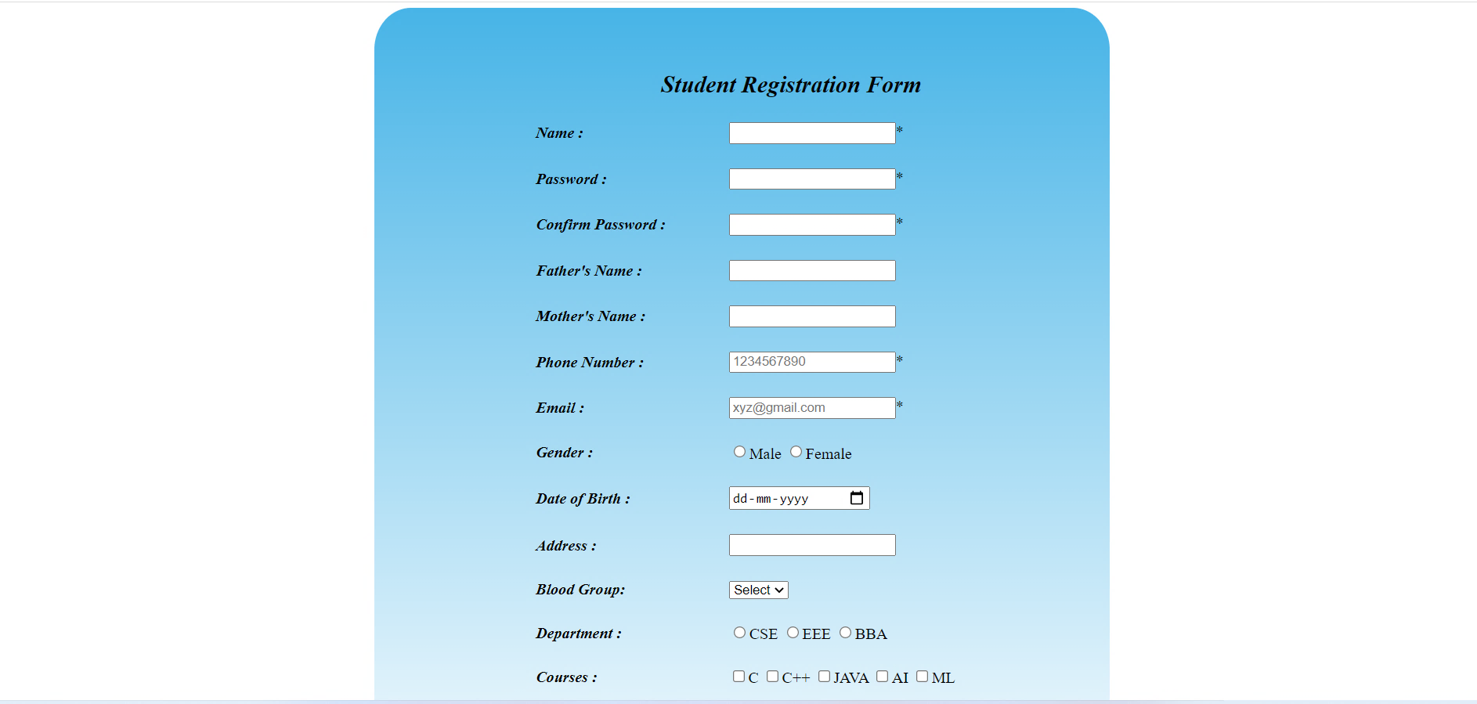

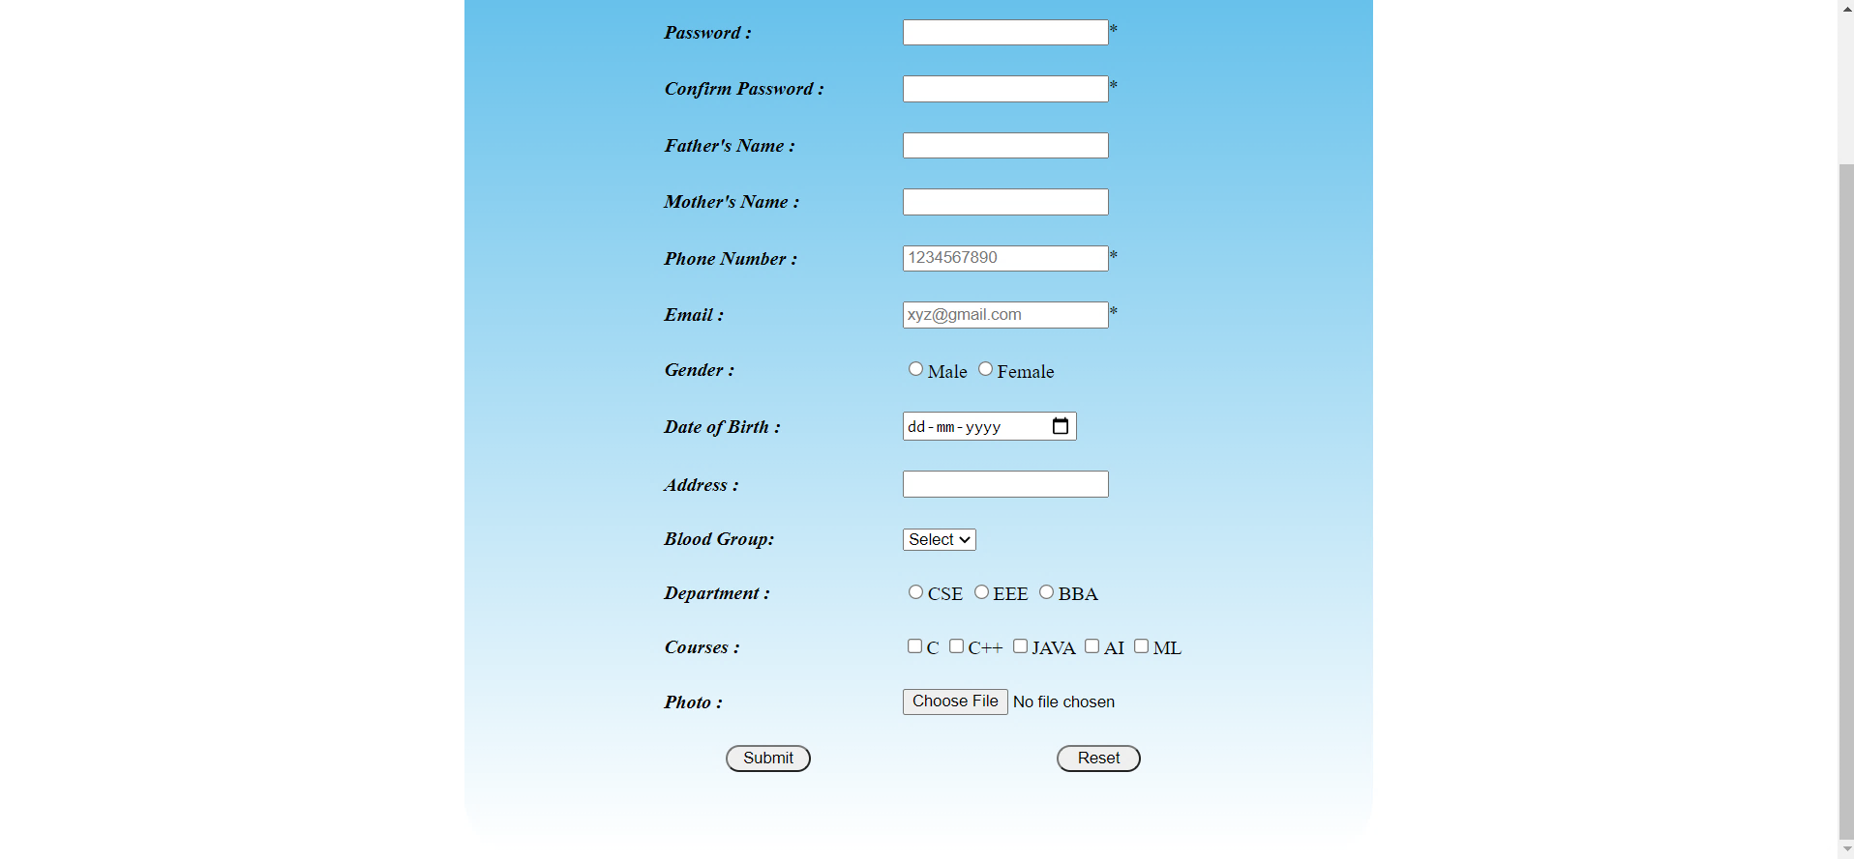

**RESULT ANALYSIS** :

<form> has been used to create an user input form.

Using <table> tag, the contents have been aligned properly.

<input> tag has as attribute type which has various values such as text, number, date, radio, checkbox etc. which can be used as per the requirement.